





**January 2016**

# Abertay Style Guidelines (Coursework & Dissertation Writing)

**Contents**

Abertay Style Guidelines (Coursework & Dissertation Writing) 1

Introduction 1

The Style (Formatting text on the page) 2

Page Layout/Setup 2

Paper Size: 2

Margins 2

Breaks 2

Fonts 3

Normal font (Body text) 3

Text Alignment 3

Italics 3

Line Spacing 4

Headings 4

Navigation 4

Working with Images 5

Inserting Images 5

Captions 5

Using Automated Table of Contents, Figures, & Tables 6

Styles and the Table of Contents 6

Table of Figures 6

Outline Numbering & Page Numbering using Section Breaks 7

Applying Outline Numbering 7

Section Breaks 7

Page Numbering 8

Title Page and Structure Guidance for Phd/Thesis 9

Page Layout 9

Sequence of material 9

Accessibility 11

Page Layout 11

Spelling 11

Referencing 11

Support and Advice 12

Workshops 12

Weekly drop-in sessions 12

## Introduction

The University is full of writers so we developed this style guide to support both experienced writers and those of us who feel are just beginning our University journey and are less experienced in writing for academic purposes.

One of the ways the guide will help will be to create a clear and consistent formatting technique to be used by students writing coursework or final year dissertations. Staff may also find this guide helpful; it is not intended to replace publisher and discipline specific style sheets which academics follow. The tips within the guide will make your documents more inclusive, giving a professional feel to communications. We hope the guide becomes a reference point for all writers, building your skills and increasing your confidence in order to build on our professional reputation. Just for completeness, we have included a section on common mistakes in spelling and punctuation. We hope you find it useful, but if you can think of any ways to make it even better – please let us know..

If you have any queries contact the Information Services:

ittrainers@abertay.ac.uk

## The Style (Formatting text on the page)

Abertay Library Services have designed a standard formatting style for academic writing of coursework and final year dissertations. This is only a guide and may differ slightly with each school. Please check your module handbook for differences.

### Page Layout/Setup

#### Paper Size:

Your page should be set to A4 by default but if this differs please see figure 1 to set this to the correct size.

#### Margins

Margins should be set to 1” all round (2.54cm). Also see Dissertation Margins for Print

#### 

Figure 1 Paper Size

#### Breaks

Using breaks such as **Page Break** and **Next Page Section** break has many benefits to working with your document. Using page breaks allows you to identify what you want on certain pages. For example, starting a new chapter on a new page. Refrain from using the carriage return to move text down to the next page.

Figure 2 Carriage return key

This will help when editing your document. Using the carriage return **(figure 2)** will only move text around making it more difficult to finalise for print.

To help with the layout of your document turn on the Ruler **(figure 3)** and the Show and Hide tool **(figure 4),** this helps you see where you have new paragraphs and other hidden formatting symbols.

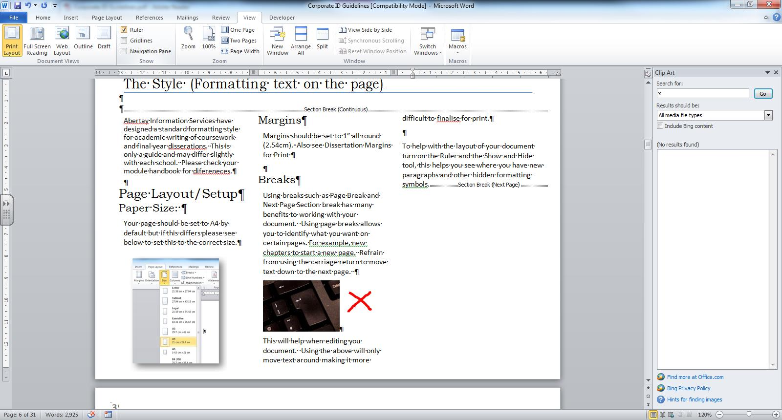

Figure 3 View Ruler.

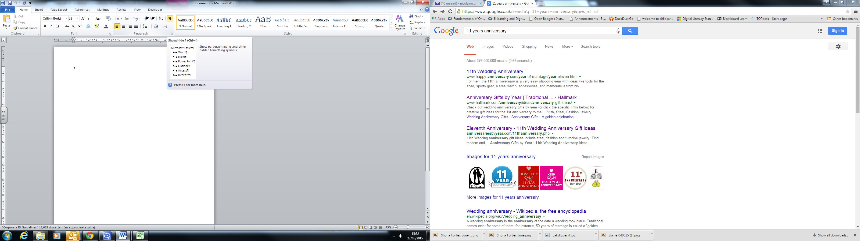

Figure 4 Show/Hide Tool

### Fonts

The type face you use can have an impact on the readability of your document. The two main types of typeface are **Serif** and **Sans Serif**, the difference between the two is that the Serif font ends in a curl or flick at the end of each character, an example of a **Serif font** would be Times New Roman.

An example of a **Sans Serif** font would be Arial. Sans Serif fonts are considered to be easier to read particularly on screen.

Sans Serif

Serif

Sans Serif fonts like Arial, Verdana and Helvetica are often used in web site design, this is because they are some of the most common fonts in use on your computer and they work well on screen.

Serif fonts are said to work better in print, but for accessibility it is often recommended that Sans Serif fonts are used as the characters are easier to distinguish for those with reading difficulties or a visual impairment.

Restrict your use of fonts in a document, too many different font types on a page can make the text hard to distinguish and can make the page look messy, instead keep to a maximum the minimum font use to two or less, perhaps using a different font for the headings to create an impact and another style for the body text.

#### Normal font (Body text)

The main text (Normal) in your coursework/dissertation should be using a sans serif font, such as:

* **Arial**
* **Calibri**
* **Tahoma**
* **Verdana.**

Use **12 point** for paragraph text in print.

For accessibility it is best to avoid using a font smaller than 12pt.

#### Text Alignment

Left aligned text is the most legible as it is easier to find the start and finish of each line. The spaces between each word are also equal. Don’t justify as this makes the text difficult to read. If text is placed against an image, make sure the straight margin is next to it, not the ragged margin.

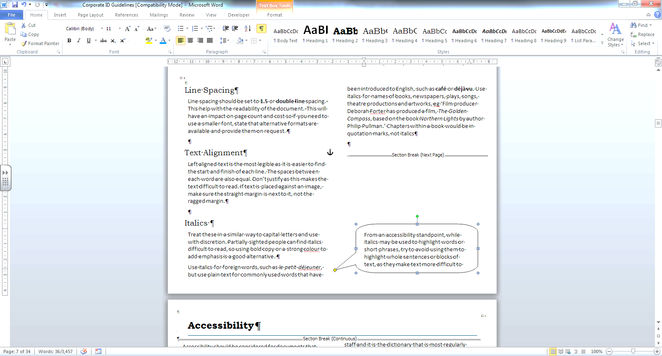

Figure 5 Left Align - Paragraph group

#### Italics

Treat these in a similar way to capital letters and use with discretion. Partially sighted people can find italics difficult to read, so using bold copy or a strong colour to add emphasis is a good alternative.

Use italics for foreign words, such as *le petit-déjeuner*, but use plain text for commonly used words that have been introduced to English, such as **café** or **déjà vu**. Use italics for names of books, newspapers, plays, songs, theatre productions and artworks, e.g. ‘Film producer Deborah Forter has produced a film, *The Golden Compass*, based on the book *Northern Lights* by author Philip Pullman.’ Chapters within a book would be in quotation marks, not italics

From an accessibility standpoint, while italics may be used to highlight words or short phrases, try to avoid using them to highlight whole sentences or blocks of text, as they make text more difficult to read.

#### Line Spacing

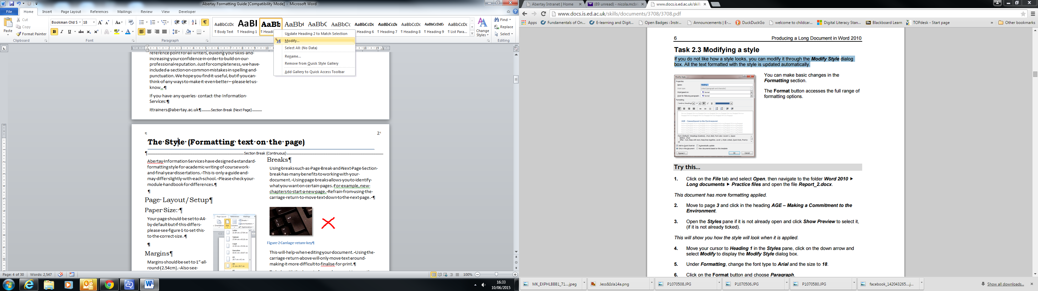Line spacing should be set to **1.5** or **double line** spacing. This help with the readability of the document. This will have an impact on page count and cost so if you need to use a smaller font, state that alternative formats are available and provide them on request.

#### Headings

Heading styles should be used where possible, using the styles Heading 1, Heading 2 ect. This helps to make your document more accessible in an electronic format.

##### Using Styles has several benefits:

* Consistency – text is always formatted in the same way
* Ease of modification – to change the appearance of text, simply modify the style and the text formatted with the style is updated to match
* Access to other features – styles allow you to make use of Word’s powerful automatic functions, such as tables of contents and cross-references

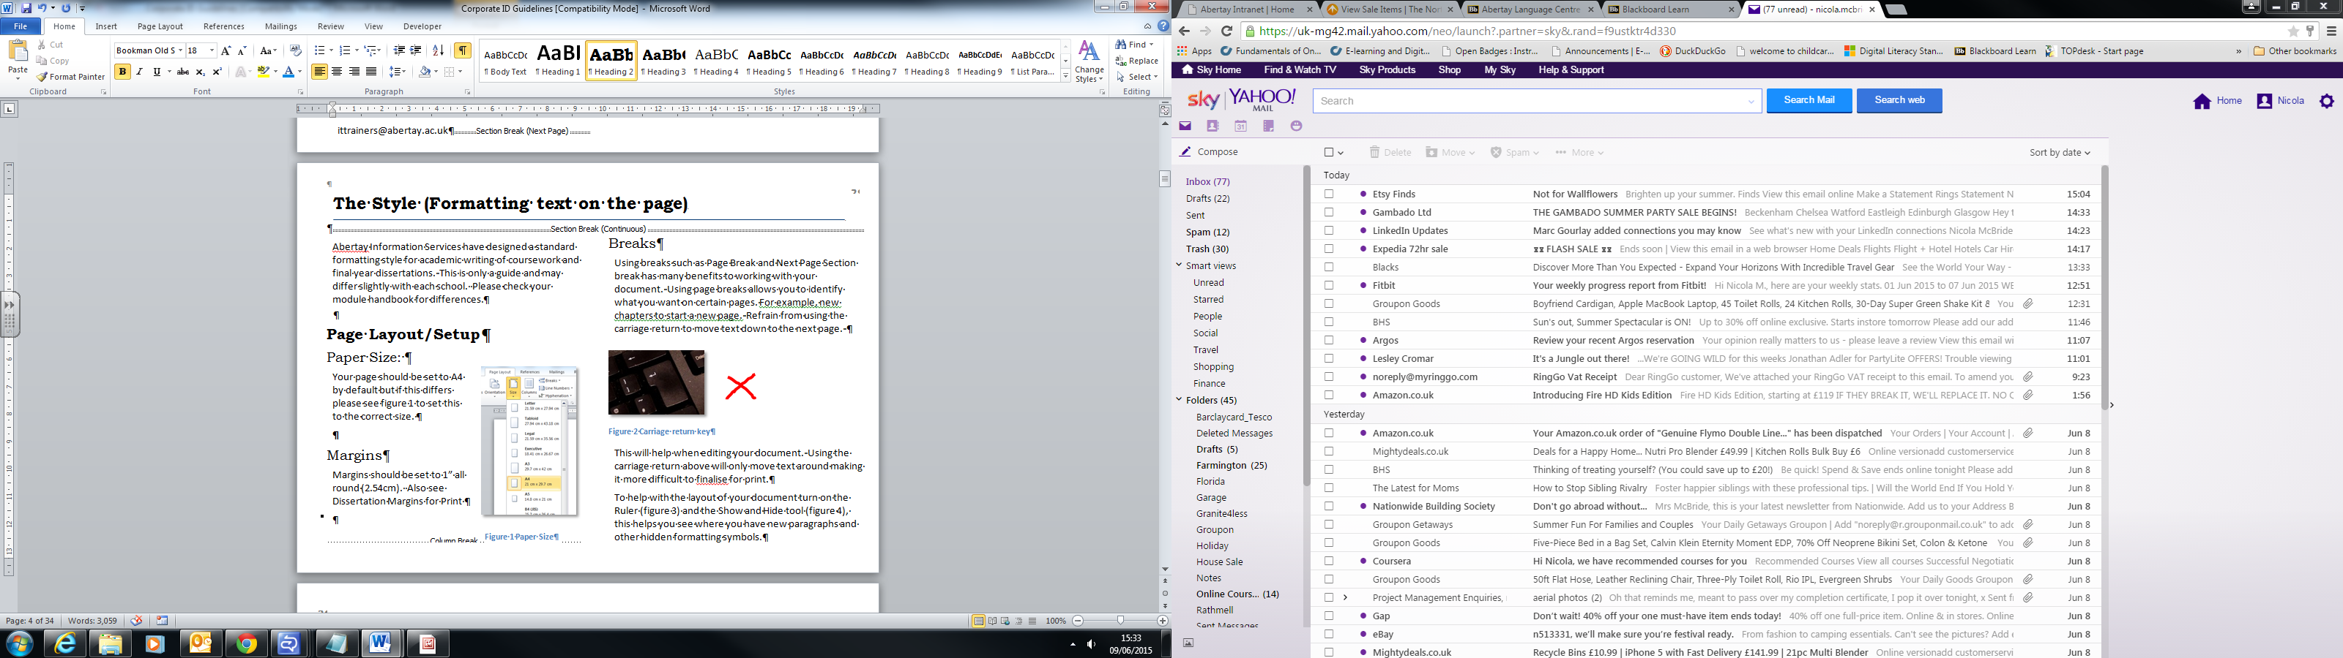

Figure 6 Styles toolbar

##### Headings Styles - Quick Guide:

Recommended formats for heading styles:

**Heading 1** – Normal font, 14pt, Bold, 1.5 line space

**Heading 2** – Normal font, 13pt, Bold, 1.5 line space

**Heading 3** – Normal font, 12pt, Bold, 1.5 line space

**Heading 4** – Normal font, 12pt, 1.5 line space

##### Modify Headings to your own style

If you do not like how a style looks, you can modify it through the Modify Style dialog box. All the text formatted with the style is updated automatically.

Figure 9 Navigation Pane

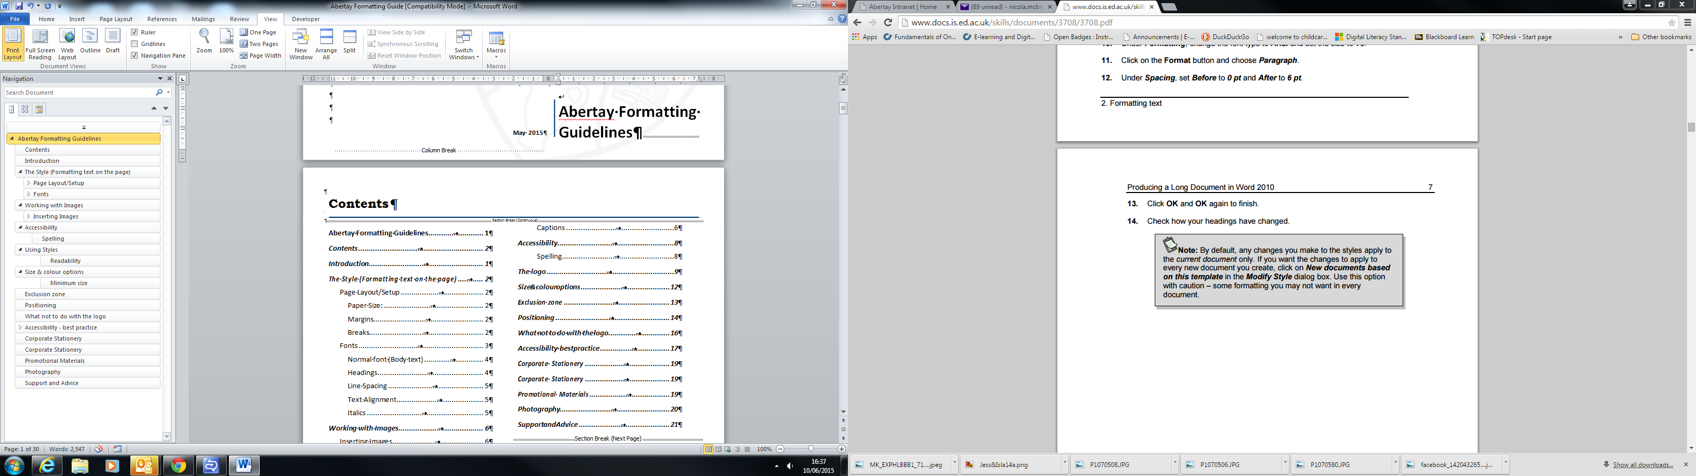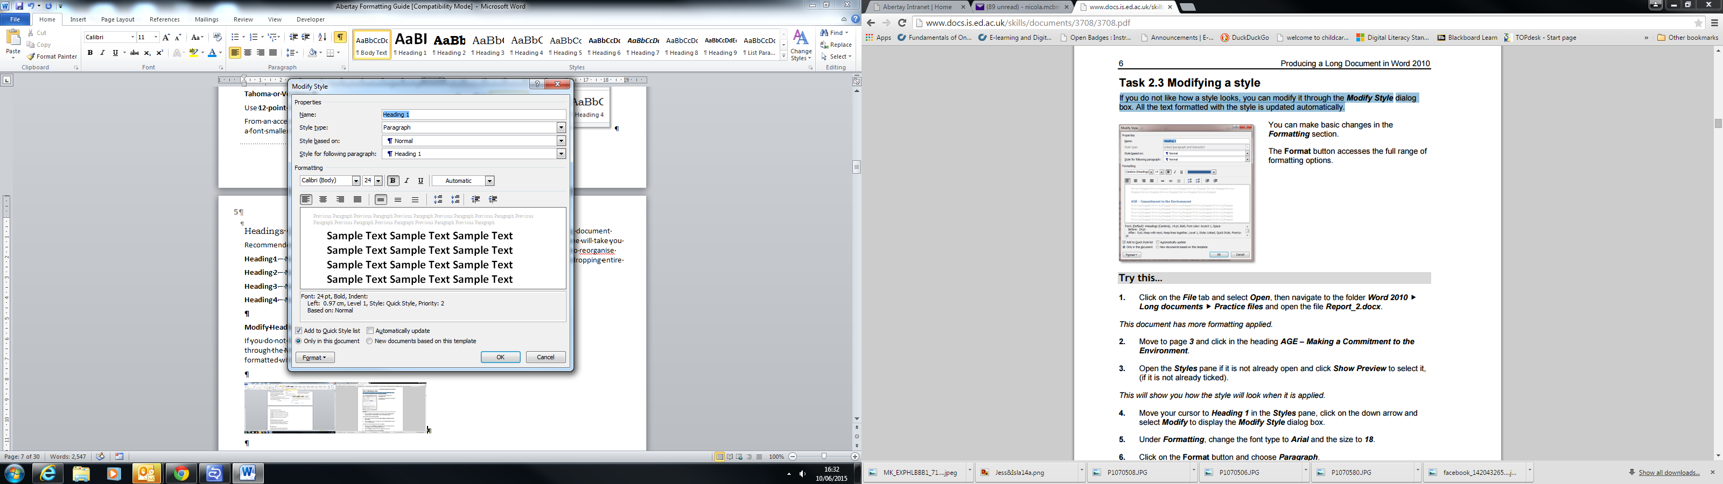

Figure 7 Modify styles Figure 8 Modify dialog box

#### Navigation

If you have applied styles, you can make use of the Navigation pane to move around a long document quickly.

Clicking on a heading in the pane will take you directly to the location, and you can also reorganise your document easily by dragging and dropping entire sections.

## Working with Images

### Inserting Images

You can insert images into you document from Microsoft image gallery or from files you have sourced yourself. Images should be inserted from the Illustrations group on the Insert tab.

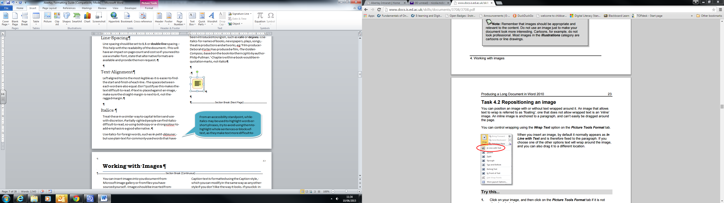

Figure 10 Inserting an image from the Illustrations group

Images should be appropriate and relevant to the content. Do not use an image just to make your document look more interesting. Cartoons, for example, do not look professional. Any images, diagrams etc. must be referenced correctly in line with copyright license, see [Referencing Guide](https://library.abertay.ac.uk/supportingyou/gethelp/referencinghelp/referencing/).

#### Captions

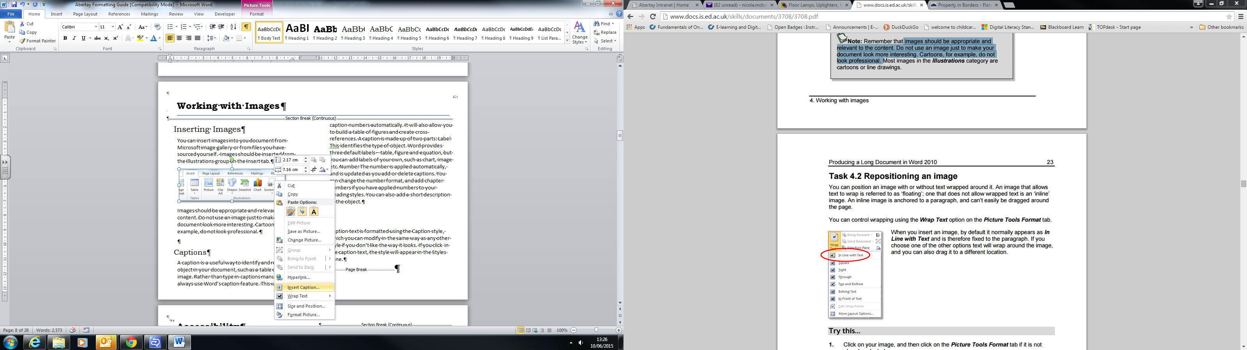A caption is a useful way to identify and refer to an object in your document, such as a table or an image. Rather than type in captions manually, always use Word’s caption feature. This will update caption numbers automatically. It will also allow you to build a table of figures and create cross-references. A caption is made up of two parts:

**Label** This identifies the type *of object. Word provides* three default labels –

* Table
* Figure
* Equation

You can add labels of your own, such as chart, image etc.

Figure 11 Right click context menu

**Number** The number is applied automatically, and is updated as you add or delete captions. You can change the number format, and add chapter numbers if you have applied numbers to your Heading styles. You can also add a short description of the object.

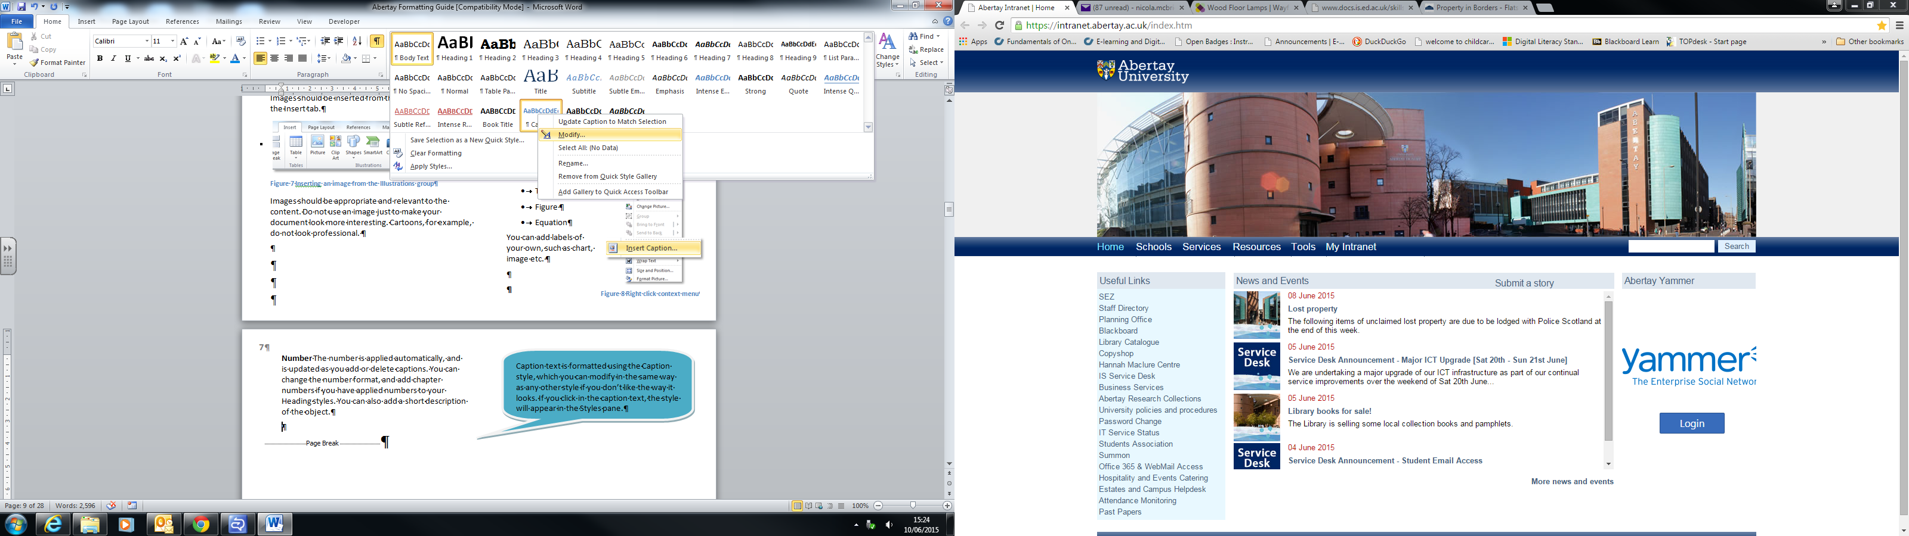

Figure 12 Modify a heading style

Caption text is formatted using the Caption style, which you can modify in the same way as any other style if you don’t like the way it looks. If you click in the caption text, the style will appear in the Styles pane.

## Using Automated Table of Contents, Figures, & Tables (Dissertations/Reports)

When creating a long, formal document, a table of contents makes it easier for your readers to navigate. You can also list items such as tables, diagrams or images in a table of figures.

Rather than typing in the contents page manually, use Word’s **Table of Contents** and **Table of Figures** functions on the **References** tab to do the hard work for you.

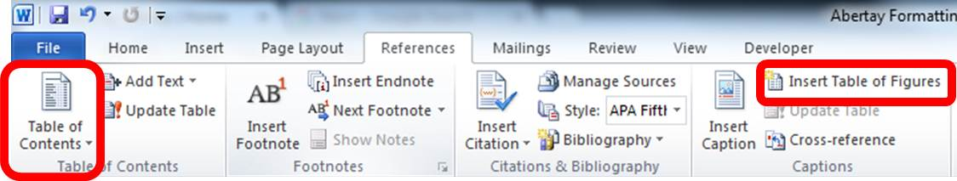

Figure 13 Reference Menu

### Styles and the Table of Contents

The most important thing to understand is that, to build a table of contents automatically, you must have formatted your headings with Word’s styles. By default, Word will use text formatted with the built-in Heading styles only to create the tables of contents. You can, however, add in any other styles, including ones you have created yourself.

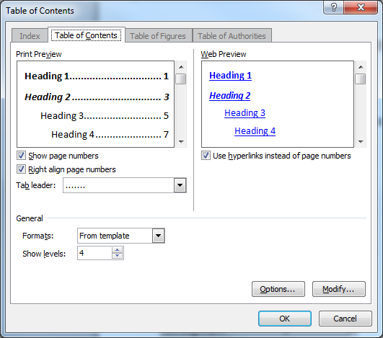

Figure 14 Table of Content dialog box

Using the dialog box Word allows more control over the content and appearance. You can choose the number of levels, select a different tab leader, and modify the table of contents styles that are used to format the text.

#### Table of Figures

If you have used Word’s caption function to label your tables **(figure 11)**, images and diagrams, you can list them in a table of figures.

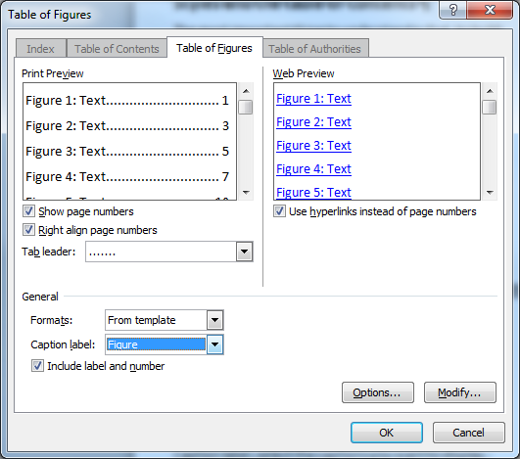

Figure 15 Table of figures dialog box

The process is similar to creating a table of contents. In Caption label, select the captions you want to display. You will have to create a table of figures for each label type you have used.

## Outline Numbering & Page Numbering using Section Breaks (Dissertations/Reports)

#### Applying Outline Numbering

To apply paragraph headings with outline numbering you should also use the automated function rather than type the numbers as you go. Once you applied the **heading styles** you should select the **Multilevel list** option in the paragraph group. You can select a different style by clicking on the arrow for more.

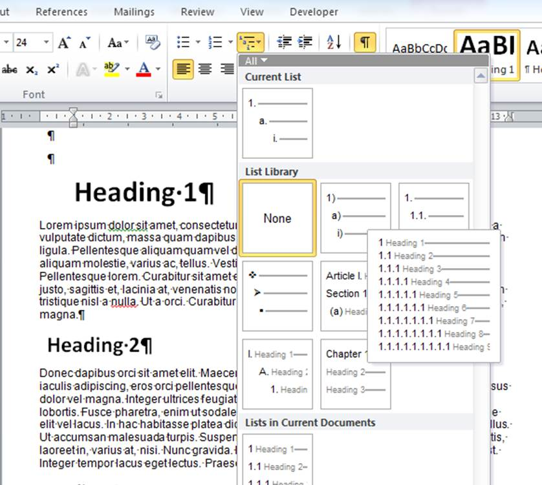

Figure 16 Multilevel list option for outline numbering

This will automatically number all your headings applied with a style, when this is automated each outline number will have a grey background. You can restart your numbering from a specific number or continue from a previous section.

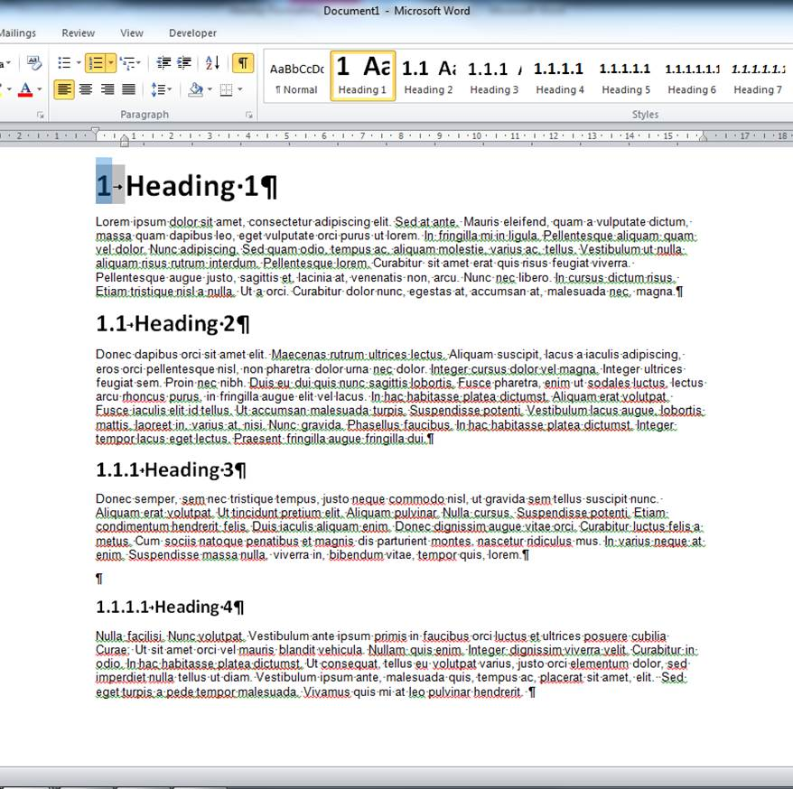

Figure 17 Outline numbering applied

#### Section Breaks

To use different page numbers or number formats and styles in different parts of your document, such as i, ii, iii…for the introduction and table of contents and 1, 2, 3… for everything after. The trick is to divide the document into sections and to make sure those sections aren’t linked.

A section break is different to a normal page break.

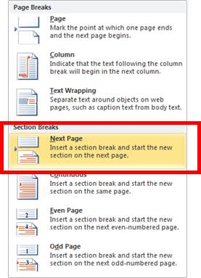To insert a section break use **Breaks** from the Page Layout Tab and select a **Next Page** from the Section breaks.

.

This will show as figure 18 when using the Show/hide tool, displaying all non-printing characters

Figure 18 Next Page section break

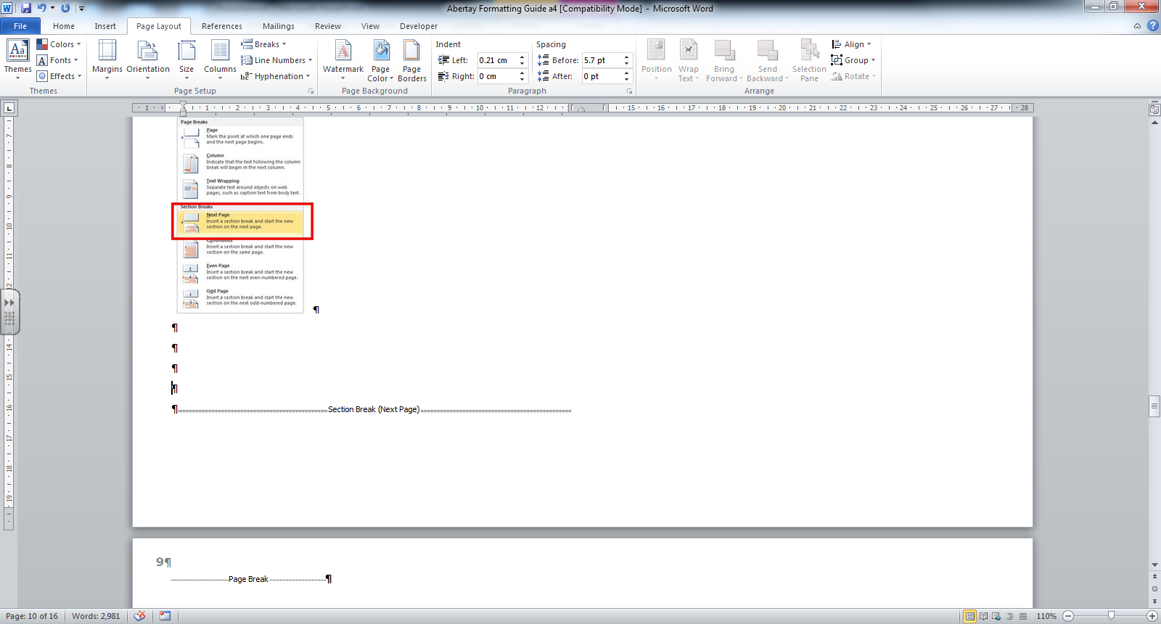

Figure 1 Section break displayed with show/hide tool

#### Page Numbering

Once you have inserted the section breaks into your document you will first need to turn off section linking. Sections are linked separately to allow the different headers and footers. If your page numbers are to be in the footer then turn off linking for footers.

One the page after the Section break double click in the footer area and click **Link to Previous** to turn it off.

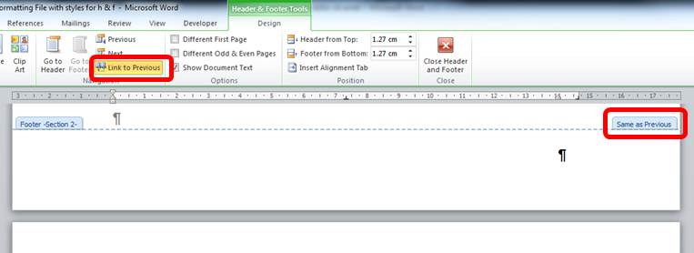

Figure 20 Section Links

Once the links are removed you can add the different page numbering to each section.

##### Insert Page numbers

In the **Header & Footer** group, click **Page Number** and then pick a location and a style.

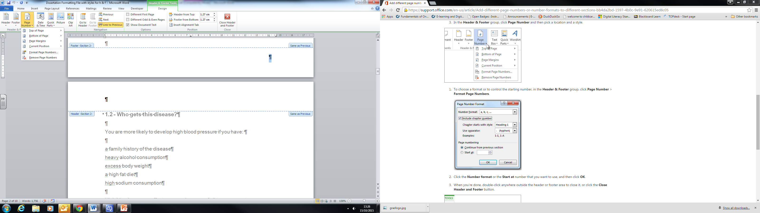

Figure 21 Inserting Page numbers

To choose a format or to control the starting number, in the **Header & Footer** group, click **Page Number** >**Format Page Numbers**.

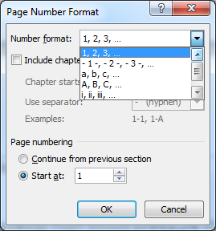

Figure 22 Number format

Click the **Number format** or the **Start at** number that you want to use, and then click **OK**.

When you’re done, double-click anywhere outside the header or footer area to close it, or click the **Close Header and Footer** button.

## Title Page and Structure Guidance for Dissertations, Phd/Thesis

### Page Layout

Margins at the binding edge must be not less than 40 mm (1.5 inches) and other margins not less than 20 mm (.75 inches). Double or one-and-a-half spacing (see Line Spacing) should be used in typescripts, except for indented quotations or footnotes where single spacing may be used.

All pages must be numbered in one continuous sequence. Numbering should follow – Title Page no numbering, preliminary pages starting from 1 in Roman numerals and from first chapter numbered Arabic numerals from 1 onwards. This sequence must include everything bound in the volume, including maps, diagrams, blank pages, etc. Any material which cannot be bound in with the text must be placed in a pocket inside or attached to the back cover or in a rigid container similar in format to the bound thesis.

### Sequence of material

Material **must** be arranged in the following sequence:

**Title**

The title page of every volume shall give the following information in the order listed, and on separate lines:

1. the full title of the thesis and any subtitle;
2. the full name of the author, followed, if desired, by any qualifications and distinctions;
3. the qualification for which the thesis is submitted (e.g., PhD or MA);
4. the name of the University;
5. the name of the Department or Centre in which the research was conducted;
6. the month and year the thesis was first submitted for examination.
7. The Abertay Logo is optional and should be out with the Title window for binding purposes.

**Abstract**

The abstract shall follow the title page. It shall provide a synopsis of the thesis, stating the nature and scope of work undertaken and the contribution made to knowledge in the subject treated. Abstract may have a different focus depending on subject area. It shall appear on its own on a single page. The abstract of the thesis may, after the award of the degree, be published by the University, and for this purpose, the copyright of the abstract shall be deemed to be vested in the University.

**Table of contents**

A list in sequence, with page numbers:

1. all relevant sub-divisions of the thesis, including the titles of chapters, sections and subsections;
2. appendices (if any);
3. the list of abbreviations and other functional parts of the whole thesis;
4. the list of references;
5. the bibliography (if any);
6. the index (if any).

**Table of Figures, illustrations, etc.**

**Table of Tables**

**Acknowledgements**

**Author's declaration**When submitting the thesis, the author shall draw attention to any material contained in it that has been presented before including the full references for any papers published or under review. If the thesis is based on joint research, the nature and extent of the author's individual contribution shall be stated. The declaration shall follow the acknowledgement, on a separate page and under a separate heading.

**Text**Divided into chapters, sections, etc.

**Appendices**  
Appendices may consist of material of considerable length or of lists, documents, commentaries, tables or other evidence that, if included in the main text, would interrupt its flow. The presentation of appendices, including character size, shall be consistent with the style of the main text.

**Definitions**  
Definitions of any terms specific to the thesis, including abbreviations and codes used in illustrations, shall be given.

**Glossary**  
Terms that require explanation shall be defined in a glossary, which shall include a key to any abbreviations used. For an abbreviation not in common use, the term shall be given in full at the first instance followed by the abbreviation in brackets.

**List of references**

**Bibliography (depending on subject/criteria)**

**Index**

## Accessibility

### Page Layout

Accessibility should be considered for documents that are going to be made available electronically such as websites and Adobe Portable Document Format (PDF) files. The accessibility of electronic content has become increasingly important with so much information being made available online. How accessible the PDF file will be, is dependent on how accessible the document it was created from was. The easiest way to produce an accessible PDF file from Word is to create a structured document by applying styles to the text such as heading 1, titles etc. Headings should follow a logical order such as Heading 1 then Heading 2. Hyperlinks can also be assigned a meaningful description, instead of including the website address as the hyperlink. Avoid using ‘Click Here’ instead use for example the name of the document or subject of the page the hyperlink is linked too. You can assign alternative text to images in Word, which will allow them to be accessible to screen reader users by giving a description of what the image is displaying.

#### Spelling

When writing on a computer, use UK version of spellcheck not the American version which is usually the default. In words where -ise and -ize are both possible, use the UK version -ise. Take care not to confuse words that sound the same but have different spellings depending on meaning or alternative American spellings.

#### Referencing

Most Abertay programmes and modules will require you to use the Harvard system of referencing. Refer to our [Abertay Harvard Quick Guide](https://library.abertay.ac.uk/media/Referencingquickguide2015-16.pdf) for guidance on the above.

If you are taking psychology modules, you will need to use the APA (American Psychological Association) style. For law modules use the OSCOLA (Oxford University Standard for Citation of Legal Authorities) style.

A referencing section in the [Abertay Learning Zone](https://blackboard.abertay.ac.uk/webapps/blackboard/execute/launcher?type=Course&id=_5988_1&url=) on Blackboard is available for all students and staff to access, both on and off campus, from the Library website.

## Support and Advice

### Workshops

We run regular workshops on specific topics in Word, PowerPoint and Excel also sessions on Referencing and finding and using resources.   <http://abertayinfoanditskills.eventbrite.com/>

### Weekly drop-in sessions

The IT Trainers and Academic Librarians run weekly drop-in sessions, offering help on Microsoft Office applications, Blackboard, PebblePlus+, SPSS, Referencing, RefWorks, and finding and using resources for your coursework, drop-in to any of the below sessions for help in the IT Training Suite, Level 2 Library.

* **Tuesday 11:00-12:00 (includes SPSS support)**
* **Wednesday 12:00-13:00**
* **Thursdays 15:00-16:00**

If you would like to find out more or to book an appointment please contact the team.

* In Person : Library Level 1 : SEZ Desk
* Email: [**isservicedesk@abertay.ac.uk**](mailto:isservicedesk@abertay.ac.uk)
* Telephone : 01382 308833

**Office hours:**Monday - Friday 09:00 - 17:00



Information Services –

Library Learning and Research Services Team